**General methodology:**

We use STORM for the generation of 10,000 years of synthetic TC tracks under given climate conditions. I will not discuss STORM in detail here, but please have a look at Bloemendaal et al. (2020) (<https://www.nature.com/articles/s41597-020-0381-2>) for a detailed description of the different model components. The present-climate STORM dataset (corresponding to the climate conditions of 1980-2017) was generated using historical TC statistics from IBTrACS (Knapp et al., 2010)

To generate the future-climate datasets, we make use of four global climate models (GCMs): CMCC-CM2-VHR4, CNRM-CM6-1-HR, EC-Earth3P-HR, HadGEM3-GC31-HM. These GCMs are run under RCP8.5 forcing for 1950-2014 and 2015-2050. The reason we use these four GCMs is because these GCMs are run at a spatial resolution of 0.25º x 0.25º, and a temporal resolution of 3 hours. Other GCMs are commonly run at coarser resolution, which is generally insufficient to adequately capture TC intensity. However, even at 0.25º x 0.25º, TC representation (especially in terms of capturing the most intense TCs) is too poor to be directly used in STORM, as this will result in a similar underestimation of TC intensity as is found in the GCMs. To overcome this, we design a novel method making use of TC information from GCMs and synthetic modeling by STORM (text below is taken from my climate change paper):

we extract information on changes in the STORM input variables from GCMs. Using the delta approach, we subsequently project these changes onto the observed TC statistics from IBTrACS (Knapp et al., 2010), which was used as input for the STORM present climate dataset (Bloemendaal et al., 2020), thereby creating a future-climate version of the historical TC statistics. Consecutively, these TC statistics are statistically extended to 10,000 years of TC activity under climate change using STORM. Finally, we convert the synthetic tracks to a 2D-wind field using a parametric model (Holland, 1980), from which we calculate the wind speed RPs at 10 km resolution.

**RCP8.5 – 2030:**

The STORM datasets that I generated in my climate change paper, represent the average climate conditions for the time period 2015-2050 under RCP8.5 forcing scenario. If we assume that the effects of climate change are approximately linear over time (which is a very crude assumption honestly, but it’s the best we can do at this time), this would mean that the 2015-2050 time period *approximately* corresponds to 2033. It is safe to assume that these conditions in 2033 will not be vastly different from those in 2030, and hence we directly use these datasets for the RCP8.5 – 2030 scenario.

**RCP8.5 – 2050:**

Unfortunately, it is not possible to directly use the GCMs the way we did for the RCP8.5 – 2030 for the RCP8.5 – 2050 scenario. That is mainly because the GCMs cover the period 2015-2050, and extracting solely the year 2050 out of this dataset would mean that we’re entirely basing our analysis on this single year, in which different climate oscillations (e.g., ENSO) will have a much more profound influence on the climate signal than when we average this out over larger time scales.

To overcome this, we calculate the 10-year running means in the 2015-2050 dataset, and extrapolate its variable values to the average conditions in 2050. This implies that we extract the important TC statistics (TC frequency, genesis locations, genesis month, MSLP and SSTs) over 10-year periods, starting with 2015-2024 (resembling the conditions in 2020) all the way up to 2041-2050 (resembling the conditions in 2046). This gives us 26 datasets to work with, which is a sufficient sample size. For the aforementioned TC statistics, we linearly interpolate (2nd-order) to the average conditions in 2050 (so, that would be the conditions over 2045-2054 ☺). We then project the differences between these 2050 conditions and the baseline conditions (GCM TC statistics over 1979-2014) onto the TC statistics extracted from IBTrACS, and run this new dataset through STORM.

**RCP4.5 analyses:**

First of all, it is important to note that we solely have access to global climate models (GCMs) that are run for RCP8.5 for 2015-2050 (as these GCMs are run at high resolution – 25 x 25 km – which allows for a better representation of TCs than in coarser-resolution datasets). To analyze climate conditions for RCP4.5 scenarios, we would like to apply a method that’s often being used in climate science: we assess the moment the RCP8.5 scenario crosses the global mean temperature value reached by a “lower” emission scenario in a given year. However, we first need to proof that we can actually do this with the GCMs data that goes into STORM. That is: can we expect to obtain (approximately) the same datasets for the RCP4.5 scenarios if we solely make use of the RCP8.5 datasets? We thus need to justify that we can actually use data from RCP8.5 to describe conditions linked to the RCP4.5 scenario.

We use STORM to simulate 10,000 years of tropical cyclone (TC) activity under different climate forcing scenarios. In STORM, the variable that has (by far) the most impact on TC intensity, is the Maximum Potential Intensity (MPI), measured in hPa. This was analyzed in Bloemendaal et al (in prep), where we conducted a sensitivity analysis to investigate a variable’s individual influence on TC category (and hence, intensity) distributions. The results are shown in Figure 1. The maximum potential intensity (MPI) is the most important driver for TC intensity, so we will focus on this variable in our RCP4.5 analyses.

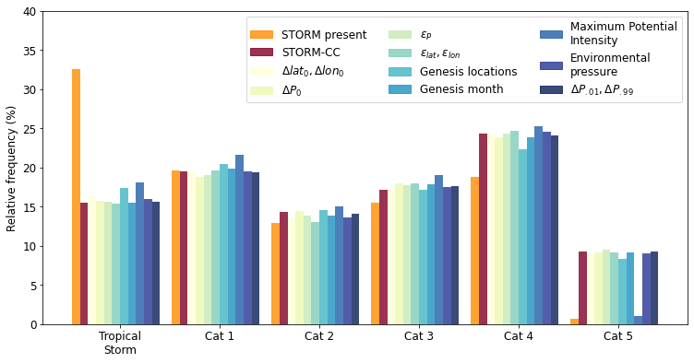

**Figure 1** Relative frequency of tropical cyclone categories for the STORM present climate run (orange) and the STORM future climate run using the climate model HadGEM3-GC31-HM in the Western Pacific. Figure taken from Bloemendaal et al (in prep).

MPI is primarily driven by sea-surface temperatures (SSTs), so it is handiest to focus on how these are going to change under climate change to justify the decisions made for the RCP4.5 analyses. For this, we use information from this paper by Ruela et al (2020) (<https://doi.org/10.1016/j.gloplacha.2020.103190>). They use 27 global climate models (GCMs) from the CMIP5 project to derive changes in SSTs between the present, near-future (2020-2050) and long-term future (2070-2100) climate for both RCP8.5 and RCP4.5. We want to use this information to see how (1) our RCP8.5 data compares to theirs and (2) our RCP8.5-equivalent compares to the “original” RCP4.5 scenario. For this, we set up a series of steps, see below:

Step 1: check how the SST distributions from our four GCMs compare to the SST distributions presented in the Ruela et al paper.

To give you a sense of what these regions are, I have plotted them below, yellow = Equatorial, green=Tropical, Blue = Subtropical, Purple=Polar. I don’t quite agree with the naming (can we really consider Spain to be tropical and Ireland to be subtropical …?) but this is the data I got from the authors.

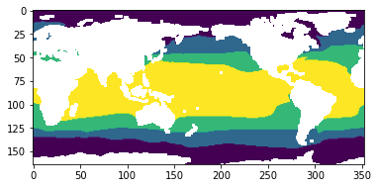

**Figure 1** Different regions used in Ruela et al (2020). Four general regions are shown, but in Ruela et al (2020) these are split up between the Northern and Southern Hemisphere to end up at eight regions.

**Table 1** Comparison of the multi-model mean and standard deviation of Ruela et al (2020) and Bloemendaal for RCP8.5 2020 – 2050.

|  |  |  |
| --- | --- | --- |
|  | Results Ruela et al | Results Bloemendaal et al |
| **Polar Region (NH)** | 0.57 ± 0.44 | 3.18 ± 2.32 |
| **Subtropical Region (NH)** | 1.18 ± 0.23 | 1.45 ± 1.34 |
| **Tropical Region (NH)** | 1.12 ± 0.18 | 1.16 ± 0.55 |
| **Equatorial Region (NH)** | 1.04 ± 0.06 | 0.97 ± 0.31 |
| **Equatorial Region (SH)** | 0.96 ± 0.04 | 0.92 ± 0.35 |
| **Tropical Region (SH)** | 0.85 ± 0.08 | 0.83 ± 0.35 |
| **Subtropical Region (SH)** | 0.71 ± 0.05 | 1.03 ± 0.9 |
| **Polar Region (SH)** | 0.47 ± 0.10 | 1.69 ± 2.05 |

So, my first step was to see how the distributions of the SSTs from the four GCMs compare to those presented in the paper. The most important regions for STORM are the tropical and equatorial regions, highlighted in green in the table. Now, similar to the paper, I have aggregated the results over all four GCMs, but I noticed that there exist some differences amongst the four GCMs (which will be interesting to see from a modelling perspective!). Conclusion first step: our aggregated set of GCMs show approximately the same change as the GCMs used in the paper, so it .

Step 2: Understand how the RCP8.5 2020-2050 data compares to the RCP8.5-2035 data in Bloemendaal.

Secondly, I want to compare how the RCP8.5 data compares to itself when we apply our own approach of the conditions of 2035 (=average over 2030-2039) being a proxy over the whole 2020-2050 period (see RCP8.5 – 2050 discussion). This way, we can justify that averaging over a smaller period still approximately resembled the conditions found over a larger time period but with the same average year.

**Table 2** Comparison of the multi-model mean and standard deviation of the GCMs used by Bloemendaal for RCP8.5 2020 – 2050 and the RCP8.5 2030 – 2039 time period. Both datasets have the year 2035 as an average.

|  |  |  |
| --- | --- | --- |
|  | Bloemendaal GCMs 2020-2050 | Bloemendaal GCMs 2030 - 2039 |
| **Polar Region (NH)** | 3.18 ± 2.32 | 3.39 ± 2.56 |
| **Subtropical Region (NH)** | 1.45 ± 1.34 | 1.56 ± 1.51 |
| **Tropical Region (NH)** | 1.16 ± 0.55 | 1.18 ± 0.61 |
| **Equatorial Region (NH)** | 0.97 ± 0.31 | 0.99 ± 0.36 |
| **Equatorial Region (SH)** | 0.92 ± 0.35 | 0.92 ± 0.36 |
| **Tropical Region (SH)** | 0.83 ± 0.35 | 0.89 ± 0.4 |
| **Subtropical Region (SH)** | 1.03 ± 0.9 | 1.11 ± 1.02 |
| **Polar Region (SH)** | 1.69 ± 2.05 | 1.79 ± 2.24 |

Step 3: Understand how the RCP4.5 2020-2050 data (from Ruela et al) compares to the RCP8.5 data in Bloemendaal

Following Step 2, I am confident that the conditions we take for 2035 resemble those over the whole 2020-2050 time period for RCP8.5. As such, I am now going to see how the RCP4.5 2020-2050 data from the paper compares to an equivalent RCP8.5 time period, to justify the shifting of the RCP curve. As the paper only lists the RCP4.5 2020 – 2050 values, this is the only data we can work with to validate our approach. Following Step 2, we may assume that the RCP4.5 2020 – 2050 conditions correspond to those in RCP4.5 – 2035. If we then use the “shifting the RCP curves”-approach, the RCP4.5-2035 scenario is equivalent to the RCP8.5-2030 scenario.

**Table 3** Comparison of the multi-model mean and standard deviation of RCP4.5 2020 – 2050 mean and standard deviations given by Ruela et al (2020) and the equivalent RCP8.5 (2030) conditions in the Bloemendaal GCMs.

|  |  |  |
| --- | --- | --- |
|  | Ruela et al RCP4.5 2020-2050 | Bloemendaal GCMs RCP8.5-2030 |
| **Polar Region (NH)** | 0.46 ± 0.37 | 2.89 ± 2.21 |
| **Subtropical Region (NH)** | 0.99 ± 0.18 | 1.32 ± 1.32 |
| **Tropical Region (NH)** | 0.95 ± 0.15 | 1.08 ± 0.59 |
| **Equatorial Region (NH)** | 0.87 ± 0.05 | 0.85 ± 0.32 |
| **Equatorial Region (SH)** | 0.80 ± 0.04 | 0.80 ± 0.34 |
| **Tropical Region (SH)** | 0.71 ± 0.07 | 0.72 ± 0.37 |
| **Subtropical Region (SH)** | 0.60 ± 0.05 | 0.93 ± 0.9 |
| **Polar Region (SH)** | 0.41 ± 0.09 | 1.63 ± 2.01 |

From Table 3, we can conclude that we can use a RCP8.5-equivalent for a given RCP4.5 scenario to generate an input dataset for STORM. This means that the “shifting the curve” is justified in our approach.

**RCP4.5 – 2030:**

**Question:** can we treat the RCP4.5 – 2030 climate scenario as being approximately equal to the RCP8.5 -2030 scenario in terms of its effects on tropical cyclones, and their wind speed return periods?

**Motivation:** If we can treat these climate scenarios as being approximately equal, we do not have to rerun STORM + the return period analysis, but we can use the RCP8.5 – 2030 datasets that were generated previously in Bloemendaal et al (in prep).

**Analysis:**

Following the previous discussion on shifting the curves for the sake of creating new STORM input datasets corresponding to the RCP4.5 scenarios, we linearly interpolate the information from Table AII.7.5 of the [IPCC report](https://www.ipcc.ch/site/assets/uploads/2017/09/WG1AR5_AnnexII_FINAL.pdf). From this, we deduce that the RCP4.5 – 2030 global mean temperatures correspond to those in 2026 in the RCP8.5 scenario. As such, we use the conditions in the year 2026 (represented by the average conditions over the 10-year period 2021 – 2031) in the GCMs as representing the RCP4.5 – 2030 climate conditions. From this, we calculate the MPI per 5º x 5º grid box in every basin, for every month, and in every GCM, and compare this to the MPI data we use to represent RCP8.5 – 2030. These results are shown in Figure 2. As the MPIs for both scenarios approximately follows the 1-1 line, we can safely assume there isn’t much difference between the RCP4.5 – 2030 and RCP8.5 – 2030 scenario, and as such my advice is to directly use the RCP8.5 – 2030 scenario to simulate RCP4.5 – 2030 conditions.

# 

**Figure 2** MPI values RCP 8.5 (2030) vs RCP 4.5 (2030) (latter calculated as RCP8.5 -2026 in the GCM data)

**Some extra info (to put things into perspective)**: Finally, I wanted to plot the MPI values for RCP8.5 – 2050 against those in RCP8.5 – 2030 to show how the MPI changes between the two datasets. This is shown in Figure 3. It is clear that the MPIs now do not follow the 1-1 line as closely as in Figure 2: there is a difference between RCP8.5 – 2050 and RCP8.5 – 2030

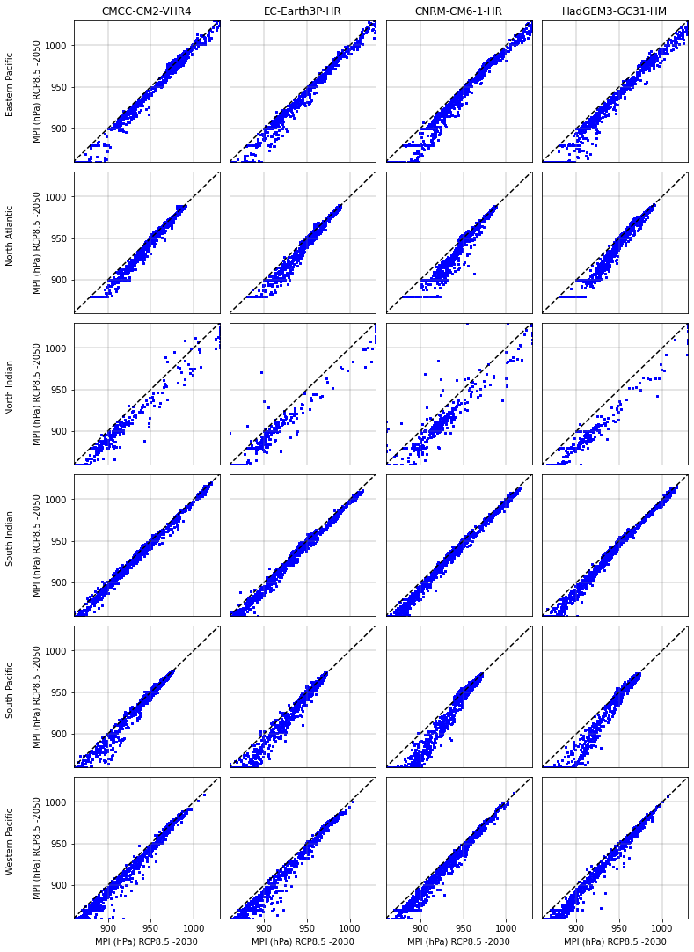

**Figure 3** MPI values for RCP 8.5 – 2030 vs RCP 8.5-2050 for all basins and all GCMs.

**RCP4.5 – 2050:**

**Using the shifting the curve-approach, the RCP4.5 – 2050 scenario approximately corresponds to the RCP8.5 – 2039 scenario**. We therefore use the RCP8.5 – 2039 datasets (these were generated in the process of deducing the RCP8.5 – 2050 conditions, see that section for more information. This dataset resembles the average conditions over 2034-2043) as input for the delta approach for STORM.

**References**

Bloemendaal, N., Haigh, I. D., de Moel, H., Muis, S., Haarsma, R. J., & Aerts, J. C. J. H. (2020). Generation of a global synthetic tropical cyclone hazard dataset using STORM. *Sci. Data, 7*(1), p 40. doi:https://doi.org/10.1038/s41597-020-0381-2

Holland, G. J. (1980). An Analytic Model of the Wind and Pressure Profiles in Hurricanes. *Mon Weather Rev, 108*(8), pp. 1212-1218. doi:https://doi.org/10.1175/1520-0493(1980)108<1212:aamotw>2.0.co;2

Knapp, K. R., Kruk, M. C., Levinson, D. H., Diamond, H. J., & Neumann, C. J. (2010). The International Best Track Archive for Climate Stewardship (IBTrACS) Unifying Tropical Cyclone Data. *Bull. Am. Meteor. Soc., 91*(3), pp. 363-376. doi:https://doi.org/10.1175/2009BAMS2755.1